**SMOKE DETECTING SYSTEM.**

# ABSTRACT

Smoke detection systems are critical components in ensuring the safety of both residential and commercial spaces. Traditional smoke detectors primarily rely on detecting particulate matter in the air, which may not always be reliable, especially in environments where false alarms can be disruptive or dangerous. In this project, we propose the development of an intelligent smoke detecting system that integrates advanced sensor technologies with artificial intelligence (AI) algorithms for more accurate and reliable smoke detection.

The proposed system utilizes a combination of optical, thermal, and gas sensors to detect various aspects of smoke, including particulate matter, temperature changes, and gas emissions. These sensors are integrated into a unified platform that continuously monitors the environment for signs of smoke or fire.

# INTRODUCTION

The Smart Smoke Detection System is an innovative project aimed at leveraging Internet of Things (IoT) technology to enhance fire safety in residential and commercial environments. Traditional smoke detectors are effective but often suffer from false alarms and limited connectivity. This project addresses these shortcomings by integrating advanced sensors with IoT capabilities to create a more intelligent and connected smoke detection solution.

The primary objective of the Smart Smoke Detection System project is to develop a reliable, accurate, and connected smoke detection solution that can provide realtime alerts and integrate seamlessly with existing IoT infrastructure.

# LITERATURE SURVEY

* ***INTERNET OF THINGS BASED ON THE SMOKE***

***DETECTING SYSTEM*** (S. B. Lakade, A. R. Pachghare, S. A. Dhotre, 2019): This paper discusses the design and implementation of a smart smoke detection system using IoT technology. It covers the selection of sensors, microcontroller, and communication protocols, along with the development of a mobile application for remote monitoring. The study evaluates the system's performance in terms of accuracy, response time, and power consumption.

* ***"AN INTELLIGENT IoT-BASED SMOKE DETECTION SYSTEM FOR SMART HOMES"*** (S. N. R. Qazi,M. H. Bhuyan, M. Rahman, 2020): This research focuses on developing an intelligent smoke detection system for smart homes using IoT technology. It explores the integration of machine learning algorithms with smoke sensors to improve detection accuracy and reduce false alarms. The study also investigates the system's ability to adapt to changing environmental conditions.
* ***"SMART SMOKE DETECTION SYSTEM USING IoT"***

(P. K. Wankhade, P. S. Lande, A. B. Jadhav, 2021): This paper presents the design and implementation of a smart smoke detection and communication protocols, as well as the development of a cloud-based platform system based on IoT technology. It discusses the selection of sensors, microcontroller, for data storage and analysis. The study evaluates the system's performance and compares it with traditional smoke detection methods.

|  |  |  |  |  |  |  |  |
| --- | --- | --- | --- | --- | --- | --- | --- |
| • | | ***INTEGRATION OF IoT WITH SMOKE DETECTION*** | | | | |  |
| ***SYSTEM FOR SMART CITIES"*** | | (A. K. Sharma, R. K.  enabled smoke detectors in urban  time data analytics and remote monitoring | | |
| Jain, 2018): This research explores the integration of IoT technology with smoke detection systems for smart cities. It discusses the challenges and opportunities associated with deploying IoT-  environments. The study also examines the potential benefits of realfor fire prevention and emergency response. | |
|  |  | | | | | | |
| • | | ***IoT-BASED SMOKE DETECTION AND FIRE*** | | | | - | |
| ***MONITORING SYSTEM FOR INDUSTRIAL*** | | |  |
| ***APPLICATION*"** | (S. S. Rathod, S. B. Rathod, 2020): This -based smoke detection and fire  monitoring system tailored for industrial applications. It discusses the selection of sensors suitable for harsh industrial environments and the integration of the system with existing industrial automation systems. The study evaluates the system's reliability, scalability, and cost | |
| paper presents an IoT  effectiveness in industrial settings. |

* **"*WIRELESS SENSOR NETWORK-BASED FIRE***

***DETECTION SYSTEM USING IoT"*** (N. R. Patil, S. S.

Londhe, S. M. Ghumbre, 2017): This research investigates the development of a wireless sensor network-based fire detection system using IoT technology. It discusses the design and deployment of sensor nodes equipped with smoke and temperature sensors for early detection of fire incidents. The study evaluates the system's performance in terms of detection accuracy and response time.

These literature sources provide valuable insights into the design, implementation, and evaluation of smart smoke detection systems using IoT technology. They cover various aspects such as sensor selection, communication protocols, data analytics, and real-world applications, contributing to the advancement of fire safety technology in both residential and industrial settings.

# TOOLS AND TECHNIQUES

For an IoT smoke detecting system, various tools and techniques can be used to create a smart, connected device that can alert users to the presence of smoke. Here are some key components and methods:

1. [**Microcontrollers**: Devices like Arduino or ESP8266 serve as the brain of the system, processing sensor data and controlling outputs1.](https://maker.pro/arduino/projects/iot-smoke-alarm-arduino-esp8266-gas-sensor)
2. [**Sensors**: The MQ2 or MQ135 gas sensors are commonly used to detect smoke and other gases in the environment2.](https://www.electroniclinic.com/iot-smoke-detector-using-mq135-gas-sensor-nodemcu-esp8266/)
3. [**Connectivity Modules**: ESP8266 Wi-Fi modules enable the system to connect to the internet and send alerts or data to a user’s device1.](https://maker.pro/arduino/projects/iot-smoke-alarm-arduino-esp8266-gas-sensor)
4. [**Indicators**: LEDs and buzzers provide visual and auditory alerts when smoke is detected1.](https://maker.pro/arduino/projects/iot-smoke-alarm-arduino-esp8266-gas-sensor)
5. **Software**: Programming the microcontroller with code that reads sensor data, sets thresholds for alerts, and controls outputs.
6. [**Web Interface**: A web page created using the ESP8266 module can display alerts and sensor readings accessible from any connected device1.](https://maker.pro/arduino/projects/iot-smoke-alarm-arduino-esp8266-gas-sensor)
7. [**Machine Learning**: Advanced systems may use machine learning algorithms to distinguish between different types of smoke and false alarms3.](https://thesai.org/Downloads/Volume15No1/Paper_9-A_Yolo_based_Approach_for_Fire_and_Smoke_Detection.pdf)
8. [**Image Processing**: Some systems use cameras and image processing techniques to visually detect smoke and fire in real-time4.](https://www.irjet.net/archives/V4/i1/IRJET-V4I1190.pdf)

[These components work together to create a responsive and reliable smoke detection system that can be monitored and controlled remotely.](https://maker.pro/arduino/projects/iot-smoke-alarm-arduino-esp8266-gas-sensor)

# ARCHITECTURE

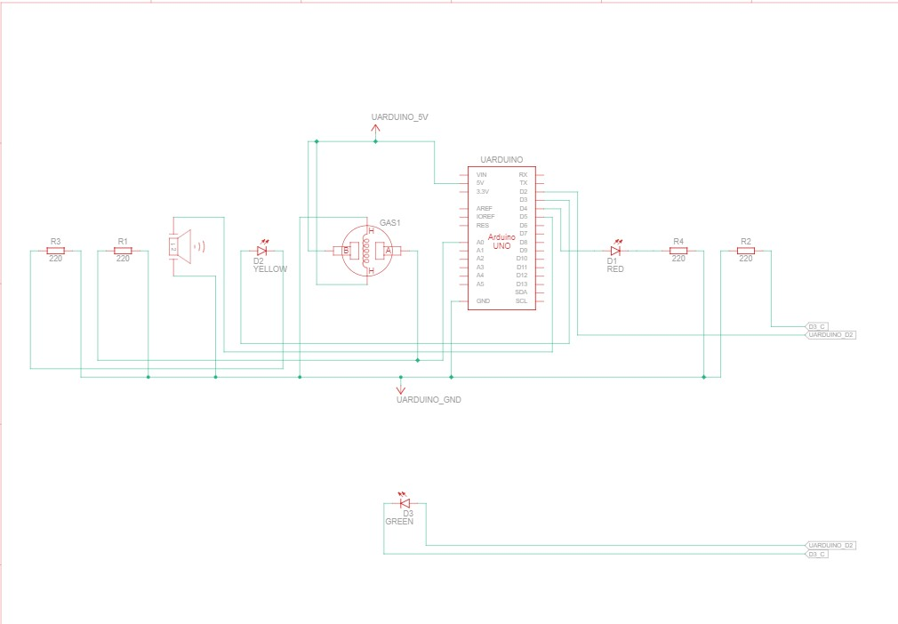

# IMPLEMENTATION

The implementation of an IoT smoke detecting system typically involves integrating various components such as smoke sensors (like the MQ2), microcontrollers (Arduino or ESP8266), and connectivity modules (Wi-Fi or Bluetooth) to create a networked alert system. The working principle is straightforward: the sensor detects smoke and sends a signal to the microcontroller, which processes the data. If smoke is detected above a predefined threshold, the system triggers an alarm and sends notifications to connected devices or a central monitoring service via the internet. This setup allows for real-time monitoring and immediate response to potential fire hazards, enhancing safety and providing peace of mind. [Advanced systems may also incorporate machine learning algorithms to improve accuracy and reduce false alarms, making them more reliable and efficient in different environments](https://link.springer.com/chapter/10.1007/978-3-031-45140-9_6)

# CODE

# define GREEN 2

# define ORANGE 3

# define RED 4

# define Buzzer 5

# define Gas_SENSOR A0

//CODE LOGIC: If no gas - green light on

// If small amount of gas detected - Orange warning will glow for 2 seconds

// Heavy smoke detected: Red light ON with Buzzer for

10 mins straight until RESET, then back to normal OP

void setup()

{

pinMode(2, OUTPUT); pinMode(3, OUTPUT); pinMode(4, OUTPUT); pinMode(5, OUTPUT); pinMode(A0, INPUT);

Serial.begin(9600);

}

void loop()

{ digitalWrite(2, LOW); digitalWrite(3, LOW); digitalWrite(4, LOW); digitalWrite(5, LOW);

int SIN = analogRead(A0);

Serial.println(SIN);

if(SIN>=45){ digitalWrite(RED, HIGH); digitalWrite(Buzzer, HIGH); delay(600000);

}

else if(SIN>=30){ digitalWrite(ORANGE, HIGH);

delay(2000);

} else{

digitalWrite(GREEN, HIGH); }

delay(10);

}

# RESULT

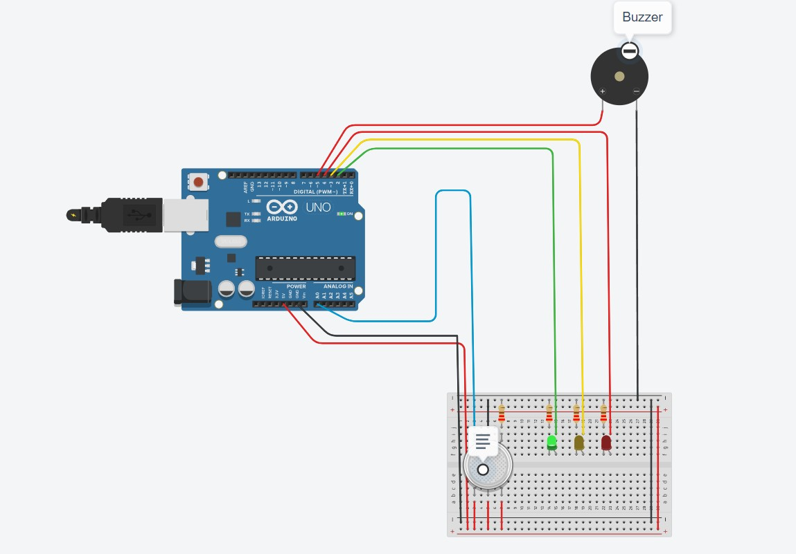

The result of an IoT smoke detecting system project would typically demonstrate the system’s ability to detect smoke accurately and alert users promptly. Such a project might involve using sensors like the MQ135 to monitor air quality and detect smoke particles. When smoke is detected, the system could send real-time notifications to a user’s smartphone or computer, possibly through an app like Blynk. The project could also include a web interface to monitor sensor readings. Advanced projects might incorporate artificial intelligence to minimize false alarms, enhancing the system’s reliability. [Overall, the project would showcase the potential of IoT technology in improving safety and responsiveness in smoke detection](https://www.electroniclinic.com/iot-smoke-detector-using-mq135-gas-sensor-nodemcu-esp8266/)

# CONCLUSION

The Smart Smoke Detection System project aims to revolutionize fire safety by combining advanced sensor technology with IoT connectivity. By providing real-time alerts, remote monitoring, and integration with smart home systems, this system offers enhanced protection and peace of mind to homeowners and businesses alike.

# FUTURE WORK

In the realm of smoke detecting systems IoT projects, future work holds exciting possibilities for further enhancing fire safety and refining the capabilities of these innovative solutions. One avenue for future research and development involves the integration of advanced technologies to augment the effectiveness and intelligence of smoke detecting systems. This includes exploring the incorporation of emerging sensor technologies, such as hyperspectral imaging or multispectral sensors, to detect smoke particles with higher precision and accuracy, even in challenging environments with varying light conditions or backgrounds. Additionally, the integration of artificial intelligence and machine learning algorithms presents promising opportunities for improving smoke detection algorithms, reducing false alarms, and enabling predictive analytics for proactive fire prevention measures. Future work could also focus on enhancing the connectivity and interoperability of smoke detecting systems with other IoT devices and smart building infrastructures, enabling seamless integration and coordination of fire safety protocols with broader building management systems. Furthermore, there is potential for exploring novel deployment scenarios and applications for smoke detecting systems, such as in unmanned aerial vehicles (UAVs) for aerial monitoring of large outdoor areas or in wearable devices for personal fire safety monitoring.

Collaborative efforts between researchers, industry stakeholders, and regulatory bodies will be crucial in driving forward the innovation and adoption of advanced smoke detecting systems IoT projects, ultimately contributing to safer environments and mitigating the devastating impacts of fire incidents inthe future.

**REFERENCE:**

In the realm of smoke detecting systems IoT projects, several scholarly articles provide valuable insights and methodologies. Lakade, Pachghare, and Dhotre (2019) discuss the implementation of an Internet of Things (IoT)-based smart smoke detection system, outlining sensor selection, microcontroller interfacing, and mobile application development. Qazi, Bhuyan, and Rahman (2020) explore the integration of machine learning algorithms with smoke sensors for improved accuracy in smart home environments. Wankhade, Lande, and Jadhav (2021) present a comprehensive study on IoT-based smoke detection systems, covering cloud integration and performance evaluation. Additionally, Sharma and Jain (2018) investigate the integration of IoT technology with smoke detection systems for smart cities, emphasizing the potential benefits of real-time data analytics. These references provide a solid foundation for designing and implementing smoke detecting systems IoT projects, offering insights into sensor technologies, communication protocols, and data analytics techniques